**OFFICE OF THE MAYOR**

26 May 2016

For submission to Council

**SUBMISSION OF THE ADJUSTMENT BUDGET FOR THE MTREF PERIOD**

**2015/16 TO 2017/18**

**PURPOSE**

The Mayor has received the mid-year assessment of performance, and decided that an adjustment budget be prepared and submitted to council.

**BACKGROUND**

The mid-year assessment of Mohokare Local Municipality has been performed and this gave rise to the instruction from the Mayor that an adjustment budget is to be prepared. The initial adjustment budget was prepared and tabled on 25 February 2016. After discussions held with the Department of Co-operative Governance regarding the property rates tariff approved for the 2015/16 financial year, it was highlighted that we are to adjust the property rates tariff downwards due to the significant increase in the value of properties in Mohokare Local Municipality. This gave rise to the tabling of the special adjustment budget to Council.

The adjustment budget is tabled in the following formats:

**Adjustment Budget Schedule**

* Table B1 - Summary See Annexure A
* Table B2 – Financial performance standard classification See Annexure B
* Table B3 – Financial performance – by municipal vote See Annexure C

**Applicable legislation and policies:**

**MFMA Act 56 of 2003**

In terms of section 28 (1) the municipality may revise an approved annual budget through an adjustment budget.

Furthermore in terms of section 28.(2) an adjustment budget:

1. Must adjust the revenue and expenditure estimates downwards if there is material under collection of revenue during the current year.
2. May appropriate additional revenues that have become available over and above those anticipated in the annual budget, but only to revise or accelerate spending programs already budgeted for.
3. May, within a prescribed framework, authorise unforeseeable and unavoidable expenditure recommended by the mayor of the municipality; may authorize the utilization of projected savings in one vote towards spending under another vote.
4. May authorize the spending of funds that were unspent at the end of the past financial year where the under-spending could not reasonable have been foreseen at the time to include projected roll-overs when the annual budget for the current year was approved by the council.
5. May correct any errors in the annual budget.
6. May provide for any other expenditure within a prescribed framework.
7. An adjustments budget must be in a prescribed form.
8. Only the mayor may table an adjustments budget in the municipal council; but an adjustments budget in terms of subsection (2) (b) to (g) may only be tabled within any prescribed limitations as to timing or frequency.
9. When an adjustments budget is tabled, it must be accompanied by:
   * An explanation how the adjustments budget affects the annual budget; - a motivation of Any material changes to the annual budget;
   * An explanation of the impact of any increased spending on the annual budget and the annual budgets for the next two financial years;
   * Any other supporting documentation that may be prescribed.
10. Municipal tax and tariffs may not be increased during a financial year except when required in terms of a financial recovery plan.
11. Section 22(b), 23(3) and 24(3) apply in respect of an adjustments budget and in such application a reference in those sections to an annual budget must be read as a reference to an adjustment budget.

**‘‘unauthorised expenditure’’**, in relation to a municipality, means any expenditure incurred by a municipality otherwise than in accordance with section 15 or 11(3), and includes—

(a) overspending of the total amount appropriated in the municipality’s approved budget;

(b) overspending of the total amount appropriated for a vote in the approved budget;

(c) expenditure from a vote unrelated to the department or functional area covered by the vote;

(d) expenditure of money appropriated for a specific purpose, otherwise than for that specific purpose;

(e) spending of an allocation referred to in paragraph (b), (c) or (d) of the definition of ‘‘allocation’’ otherwise than in accordance with any conditions of the allocation; or

(f) a grant by the municipality otherwise than in accordance with this Act;

**Mid-year budget and performance assessment**

72. (1) The accounting officer of a municipality must by 25 January of each year—

(a) assess the performance of the municipality during the first half of the financial year, taking into account—

(i) the monthly statements referred to in section 71 for the first half of the financial year;

(ii) the municipality’s service delivery performance during the first half of the financial year, and the service delivery targets and performance indicators set in the service delivery and budget implementation plan;

(iii) the past year’s annual report, and progress on resolving problems identified in the annual report; and

(iv) the performance of every municipal entity under the sole or shared control of the municipality, taking into account reports in terms of section 88 from any such entities; and

(b) submit a report on such assessment to—

(i) the mayor of the municipality;

(ii) the National Treasury; and

(iii) the relevant provincial treasury.

**Municipal Budget Circular for the 2015/16 MTREF**

This circular provides further guidance to municipalities and municipal entities for the preparation of their 2014/15 Budgets and Medium Term Revenue and Expenditure Framework (MTREF). It must be read together with MFMA Circulars No. 48, 51, 54, 66, 67, 70, 74 and 75.

**DISCUSSION – PREPARATION AND OTHER DETAILS:**

***Executive summary***

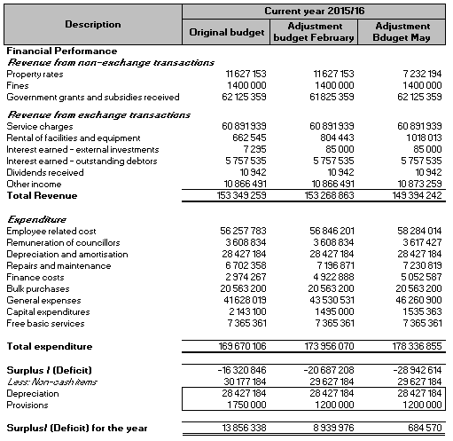

***Revenue***

The decrease in the budget for revenue was brought on by the change in tariffs regarding property rates.

During April 2016 a meeting between the Department of Co-operative Governance and Mohokare Local Municipality was held in Pretoria to discuss the implementation and interpretation of the Municipal Property Rates Act.

Find below a brief summary of the discussions which informed the proposed decrease in the tariffs relating to property rates.

During this discussion Section 3(b) of the Amendment Act, which amends section 3(3)(b)(iv) of the principal Act by requiring that a municipality determines criteria to be applied if rates are decreased. This amendment was included to explicitly draw the attention of municipalities to the fact that instead of focusing only on increasing rates, municipalities must be mindful of the need to decrease rates where applicable. The decrease in rates is of particular importance when a new valuation roll is implemented and the market values of properties have increased significantly. This exercise can prevent unnecessary outcry by ratepayers as a result of rates accounts that are increased significantly in the cent in the Rand rates are not adjusted downwards with the implementation of a new valuation roll.

Section 12(2) of the principal Act states the following:

*“(2) The levying of rates must form part of a municipality’s annual budget process as set out in Chapter 4 of the Municipal Finance Management Act. A municipality must annually at the time of its budget process review the amount in the Rand of its current rates in line with its annual budget for the next financial year.”*

In undertaking the mandatory annual review of the cent in the Rand rates, a municipality must take the market values of properties in the valuation roll and how these ultimately impact on the rates payable by ratepayers. A municipality must not focus only on the financial needs of the municipality; these must be balanced with the affordability of rates for the ratepayers. A balanced approach will also result in better relations with ratepayers.

Taking the above into account, decreases in property rates as follows are proposed:

|  |  |  |
| --- | --- | --- |
| **Category** | **Initial approved tariff 15/16** | **Proposed new tariff 15/16** |
| Residential | 0.007380 | 0.006273 |
| Commercial | 0.009998 | 0.008498 |
| Government | 0.003489 | 0.002966 |
| Agricultural | 0.001594 | 0.001100 |

The impact of this proposed decrease in property rates will have the following effect on the revenue budget:

* Decrease in total revenue (including capital grants and transfers) of 2.53%
* Decrease in self-generated revenue (including electricity sales) of 4.5%
* Decrease in self-generated revenue (excluding electricity sales) of 7.07%

The table below sets out the impact on property rates revenue per category:

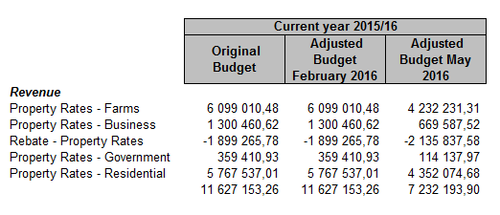

***Expected expenditure***

General comments:

All expenditure items were evaluated on a line by line basis and adjustments where applicable was discussed with the relevant directorate.

Where identified, an adjustment to the budget for certain expenditures were made as discussed below:

Salaries

An increase in the total budget for salaries was made mainly in respect of the budget for overtime. This factor is mainly affected by the water shortages in Rouxville where overtime has to be worked to ensure that service delivery to the residents of Rouxville and Roleathunya are maintained. The increase in the budget for employee related costs amounts to 2.39%.

Audit Fees

An increase in the budget for audit fees of R1,5 million was made to make provision for the audit fees charged in respect of the 14/15 audit (only billed in the 15/16 financial year). This increase in audit fees was brought on mainly by the additional audit work that the AGSA had to perform in respect of the audit on irregular expenditure dating back to the 2009/10 financial year.

**Reconciliation of adjustment budget tabled 25 February 2016 to adjustment budget tabled 26 May 2016**

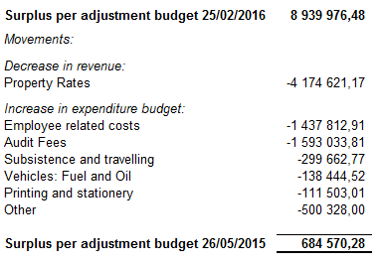

**FINANCIAL IMPLICATIONS**

Should Treasury find that the reporting received from Mohokare Local Municipality is not up to standard, they could withhold Equitable Share hampering the service delivery of Mohokare Local Municipality.

**LEGAL IMPLICATIONS**

Compliance with Section 28 (1) of the Municipality Finance Management Act No, 56 of 2003

**PARTIES CONSULTED**

The Municipal Manager, Chief Financial Officer, IDP Manager

**RECOMMENDATION**

1. It is recommended that Council approves of the adjustment budget of the municipality for the financial year 2015/16 as well as the two projected outer years 2016/17 and 2017/18 as further set out in the following annexures.
   1. Table B1 - Summary See Annexure A
   2. Table B2 – Financial performance standard classification See Annexure B
   3. Table B3 – Financial performance – by municipal vote See Annexure C
2. It is recommended that Council approves the new tariffs relating to Property Rates as set out in the report.

**COMPILED BY:**

**_____________**

**AM SHASHA**

**MAYOR**